User Login Page :-

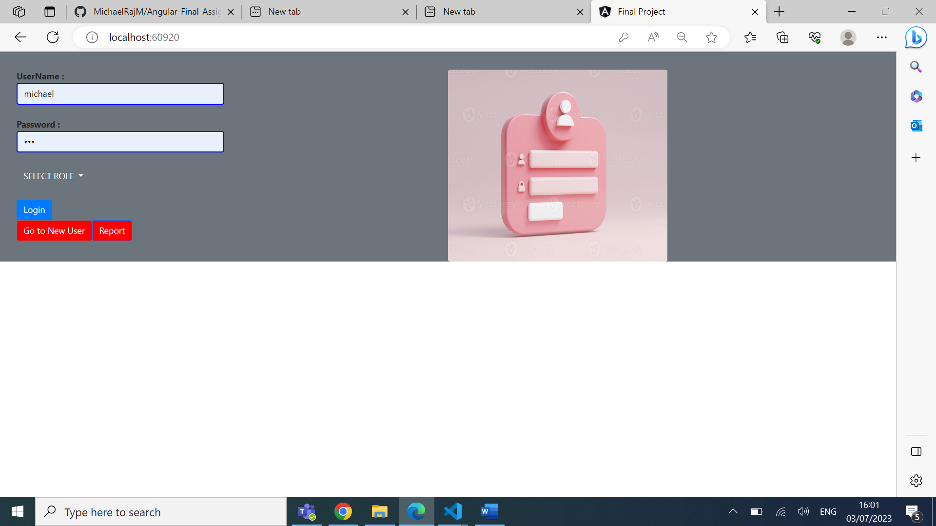

User roles (ie, **Customer,Admin,New user**)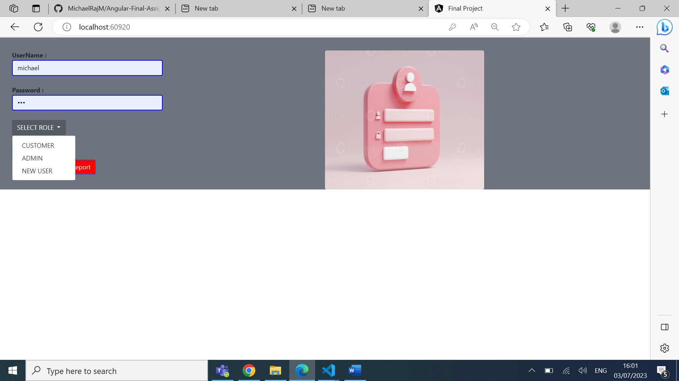

New User Creation (Sign up Form)

Product Master Entry Form: -

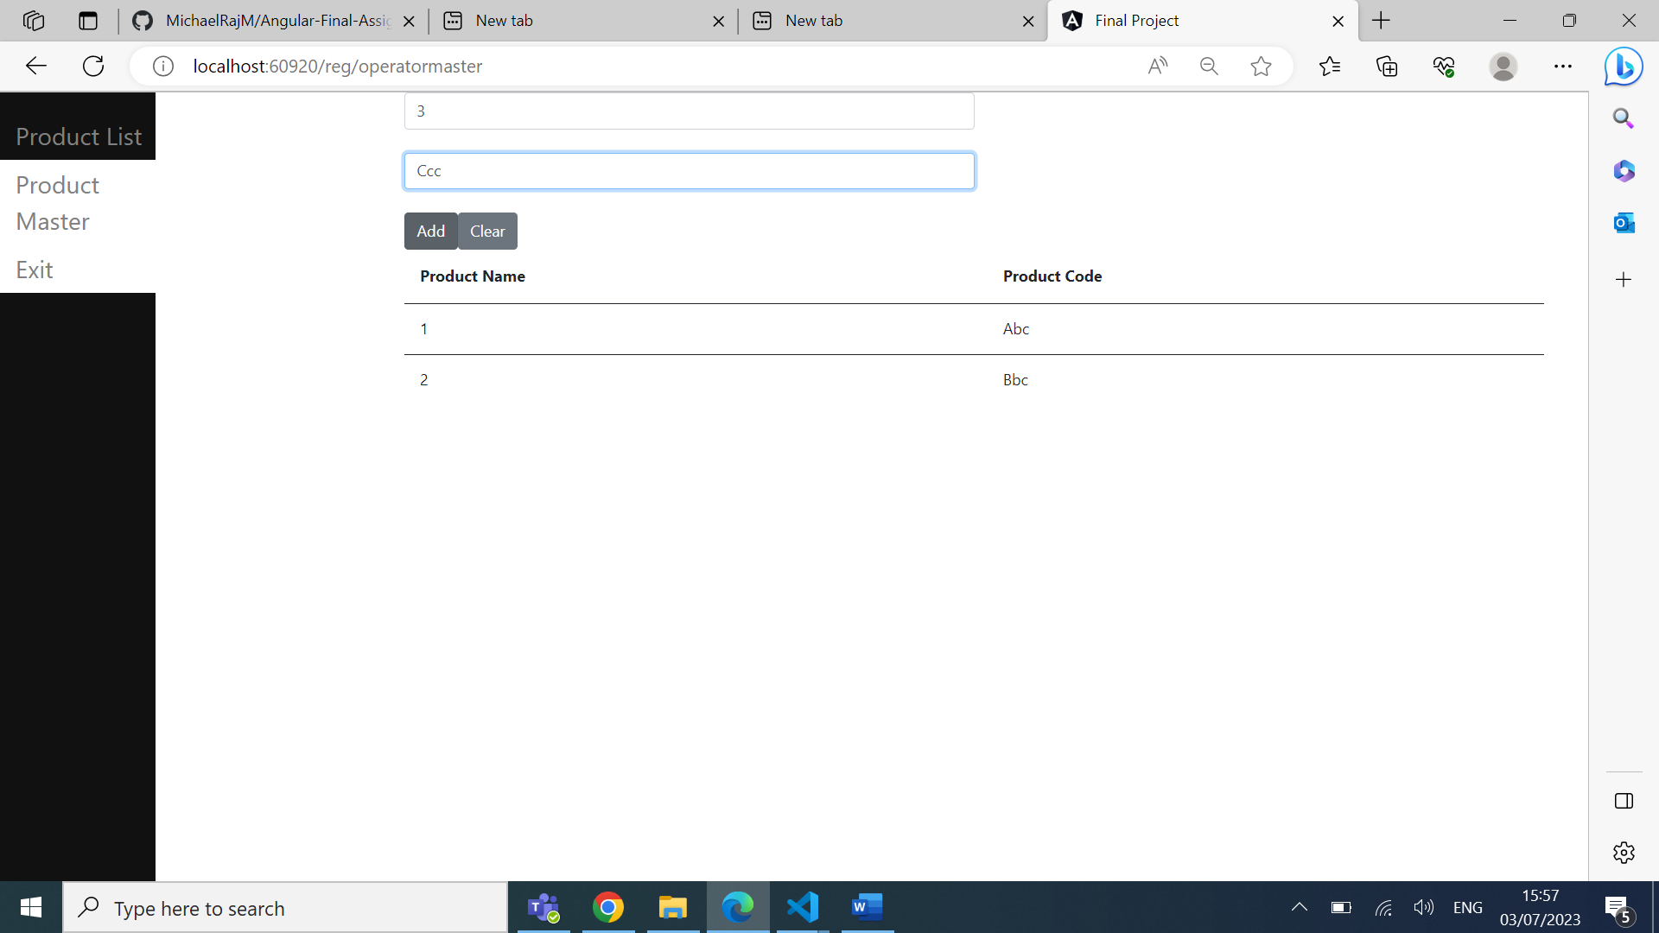

Product List View Form From .

If I click Report’s in Login page

